Are we there yet?

Dear Parents/Guardians,
In our new theme, your child will explore where in the world they’d like to go and how they would like to travel there.
We will be looking at the following…
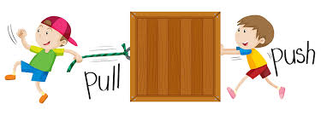
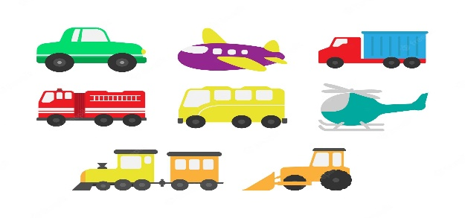

How things move.
Different types of transport.

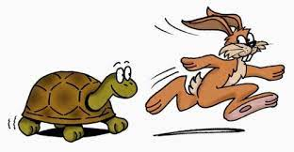


Fast and slow.
Different holiday destinations.




Keeping safe on pavements and roads.
Imaginary and real journeys

Explore these words below together and explain what each mean. Can your child use these words correctly in a sentence?

aeroplane airport bike boat bus fast holiday journey map travel walk river pavement road route safety truck school world scooter shop slow suitcase train transport vehicle
Supporting your child at home
- Take a walk around your local area and look at all the different types of transport you can see. Talk about all the sights and sounds. Can you see any road signs or road markings?
- Try some physical activities like a bike or scooter ride around the park.

Alongside this theme we’ll be looking at signs of Autumn and using our outdoor areas/orchard as frequently as possible, weather dependent!

Thank you for your continued support,

Mr G. Stephens

